LAB 8
Tạo Trello
Link: https://trello.com/invite/b/6a226c191f3a58d45563becf/ATTI7b9302cef49010673c51f0cb03e99a737D1FA9C2/quản-li-dự-an-khach-sạn
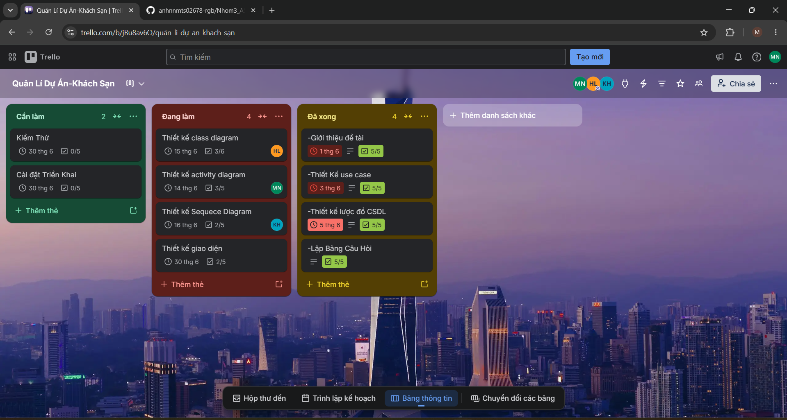

Tạo GitHub:
Link: https://github.com/anhnnmts02678-rgb/Nhom3_ASM_Quanlikhachsan
